**Name of the Authors:**

* Shubham Kumbhar
* Devdatt Khilari
* Atharva Athanikar
* Sahil Borkar

**Title of the copyright:**

# “Kisan Mitra: Transforming Agriculture with Next-Gen Disease Detection and Prediction”

**Copyright Work:**

Our application assists farmers in diagnosing crop diseases and provides personalized treatment plans to ensure healthy and productive crops. Tailored to both urban and rural users, it offers specific recommendations that cater to the unique challenges of each farming environment. By leveraging advanced technology, the app empowers farmers to make informed decisions and adapt their practices effectively. With a focus on enhancing agricultural productivity, it aims to promote sustainable farming methods. Ultimately, our solution supports farmers in achieving optimal crop health and yield.

Below given is the diagrammatic architecture of the proposed system:

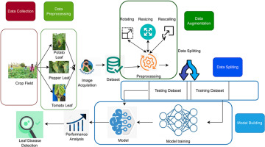

Fig. 1 Architecture of Kisan Mitra: Transforming Agriculture with Next-Gen Disease Detection and Prediction.

There are two main functionalities of the system:

1. **Crop Disease Remedy Prediction/Solution**: Our application helps farmers diagnose crop diseases and get personalized treatment plans for healthy and productive crops.
2. **Recommendation for urban and rural users**: Our application helps farmers diagnose crop diseases, get personalized treatment plans, and adapt to urban or rural farming environments for healthy and productive crops.

# Algorithm for Verification/Authentication Procedure:

1. **Data Collection:** Gathering images of healthy and diseased leaves.
2. **Data Preprocessing:** Preparing the collected images for model training.
3. **Image Acquisition:** Acquiring images from various sources (e.g., crop fields).
4. **Data Splitting:** Dividing the dataset into training and testing sets.
5. **Model Building:** Creating a machine learning model (e.g., Using sklearn libraries, random forests, linear regression, SVM, decision tree, etc.).
6. **Model Training:** Training the model on the training dataset.
7. **Model Testing:** Evaluating the model's performance on the testing dataset.
8. **Performance Analysis:** Analyzing the model's accuracy, precision, recall, and other metrics.